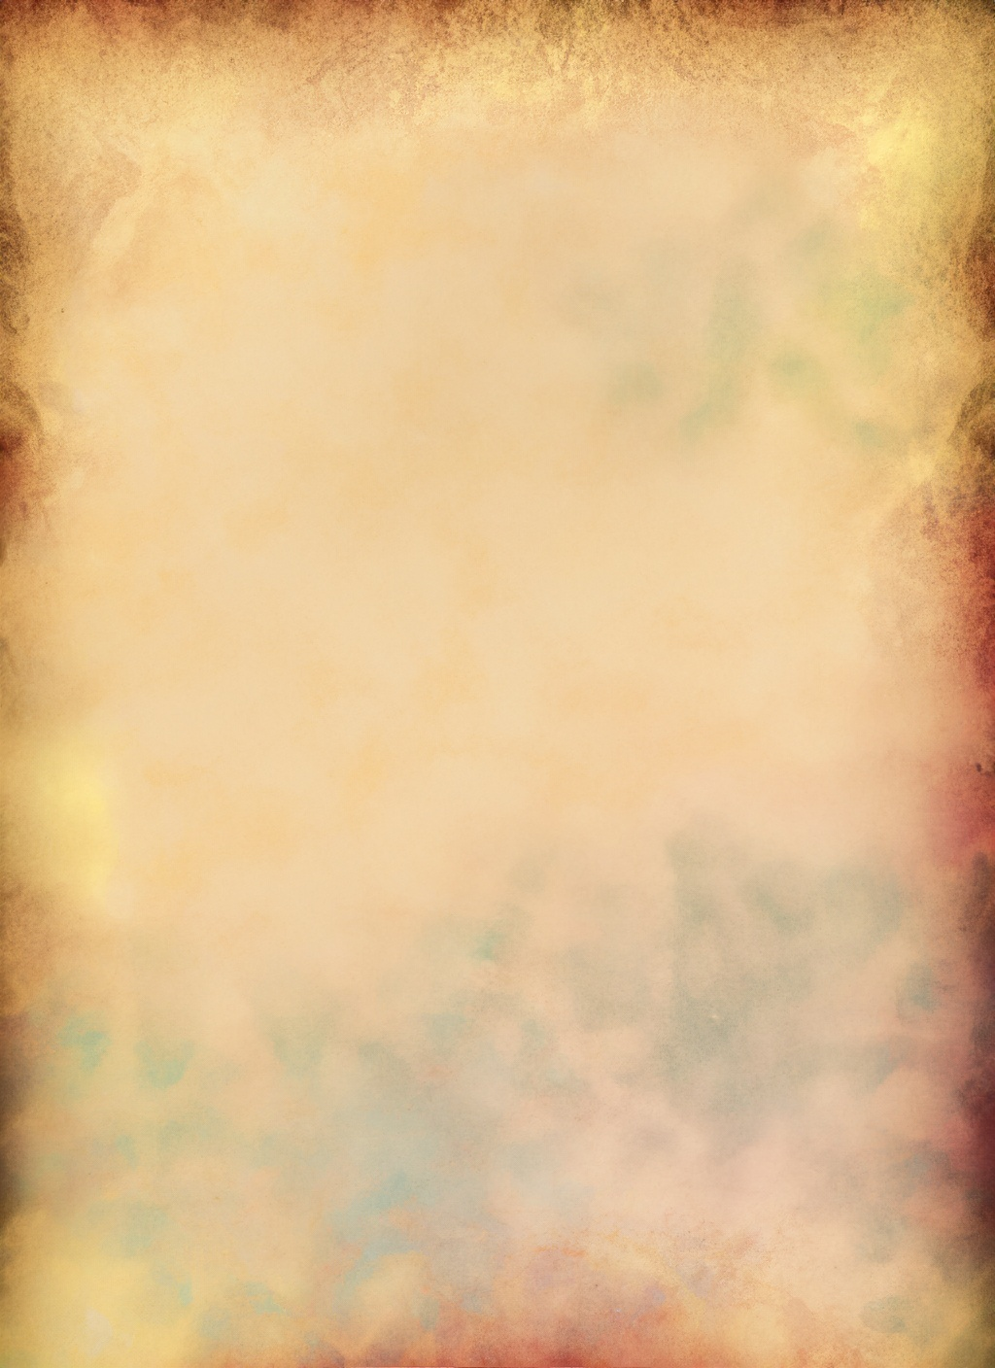**Méthode Design System**

A Design System is a **library of components** (colors, buttons, fonts, etc.) that ensures **visual and functional consistency** across all products.

**Benefits:**

1. **Reusable** : saves time by using the same elements
2. **Consistent** : Makes interfaces clearer to users
3. **Documented** : everything is explained (rules, usage, styles...)
4. **Collaborative** : aligns designers, devs, and project managers

**Game tip:** thanks to the Design System, your team saves **2 logs to** build the raft!

